S P R I N T-

4

|  |  |
| --- | --- |
| TEAM ID | PNT2022TMID51290 |
| Project Name | IoT Based smart crop Protection system for agriculture |
| Maximum mark | 20 marks |

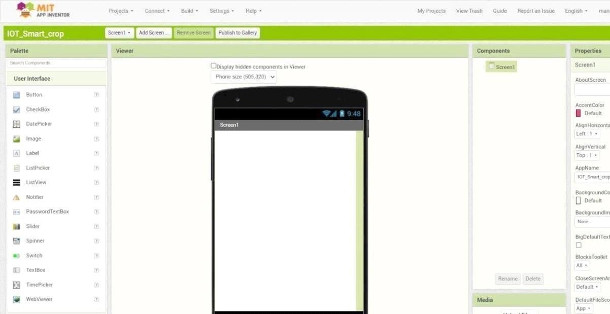STEP 1: MIT APP inventor to design the APP.

STEP 2: Customize the App interface to Display the Values.

